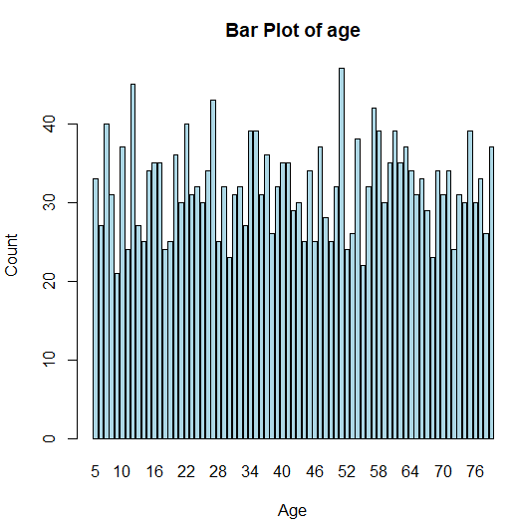
1. Bar Plot of Categorical Variable (e.g., Age)
barplot(table(data$Age),
col = "lightblue",
main = "Bar Plot of age",
xlab = "Age", ylab = "Count")

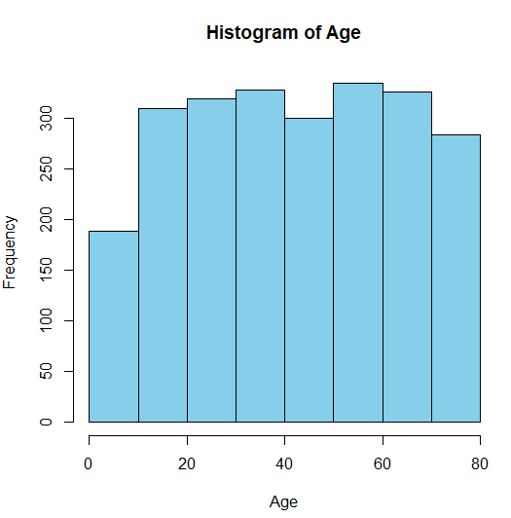
2. Histogram of Numeric Variable (e.g., Age)
hist(data$Age,
col = "skyblue",
main = "Histogram of Age",
xlab = "Age", breaks = 10)

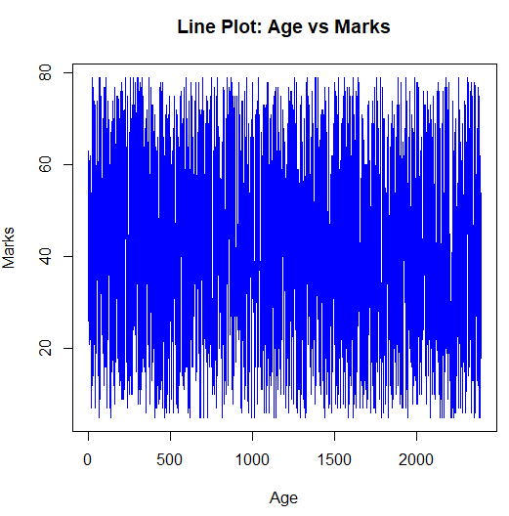
3. Line Plot (e.g., Marks over Age)
plot(data$Age, data$Marks,
type = "l",
main = "Line Plot: Age vs Marks",
xlab = "Age", ylab = "Marks",
col = "blue")

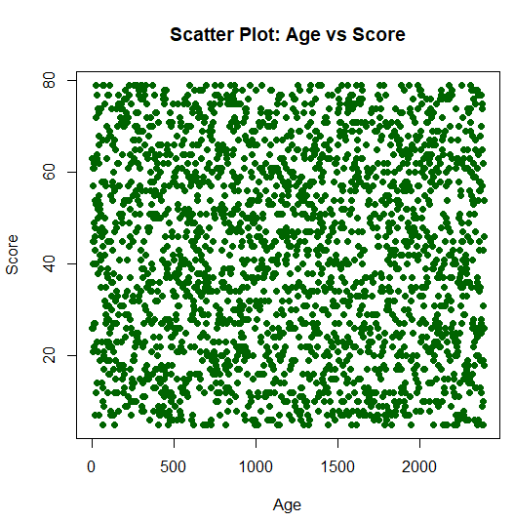
4. Scatter Plot (e.g., Age vs Score)
plot(data$Age, data$Score,
main = "Scatter Plot: Age vs Score",
xlab = "Age", ylab = "Score",
pch = 19, col = "darkgreen")

Step 1: Load the CSV File
data <- read.csv("a2.csv")

Step 2: Inspect the Data
head(data)
str(data)
names(data)
summary(data)

Step 3: Plot Common Graphs
Histogram of Age
hist(data$Age,
main = "Histogram of Age",
xlab = "Age",
col = "lightblue", breaks = 10)

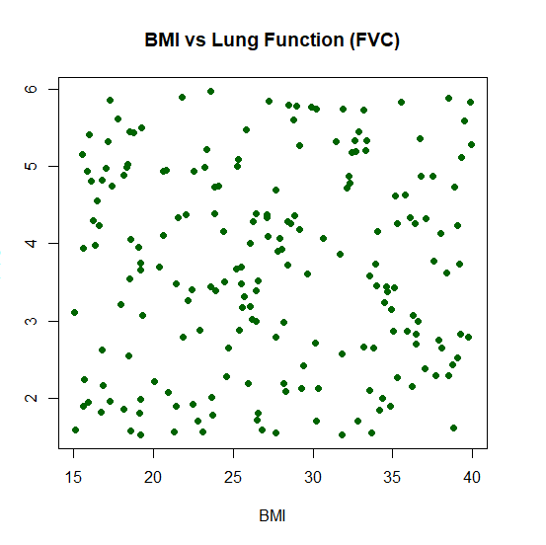
Scatter Plot: BMI vs Lung Function FVC
plot(data$BMI, data$LungFunctionFVC,
main = "BMI vs Lung Function (FVC)",
xlab = "BMI",
ylab = "FVC",
pch = 19, col = "darkgreen")

Line Plot: Sleep Quality vs Age
plot(data$Age, data$SleepQuality,
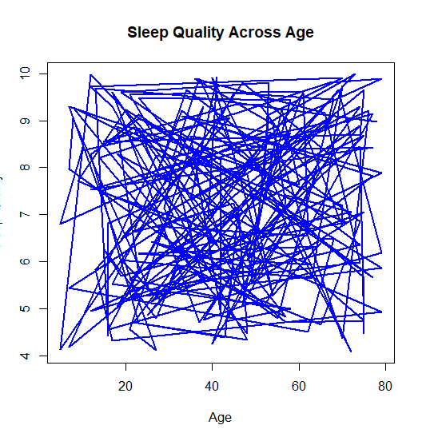
type = "l",
main = "Sleep Quality Across Age",
xlab = "Age", ylab = "Sleep Quality",
col = "blue", lwd = 2)

Barplot: Average FEV1 by Dust Exposure Level
avg_fev1 <- tapply(data$LungFunctionFEV1, data$DustExposure, mean, na.rm = TRUE)
barplot(avg_fev1,
main = "Average FEV1 by Dust Exposure",
xlab = "Dust Exposure",
ylab = "Average FEV1",
col = "purple")

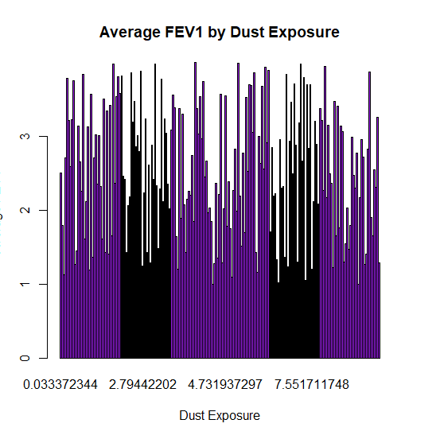
Using ggplot2 for Prettier Plots
install.packages("ggplot2") # Only once
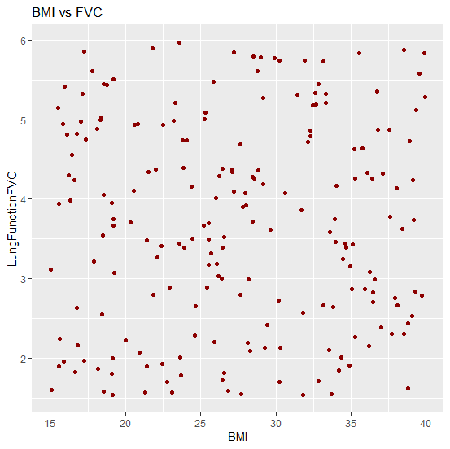
library(ggplot2)

Scatter Plot
ggplot(data, aes(x = BMI, y = LungFunctionFVC)) +
geom_point(color = "darkred") +
labs(title = "BMI vs FVC")

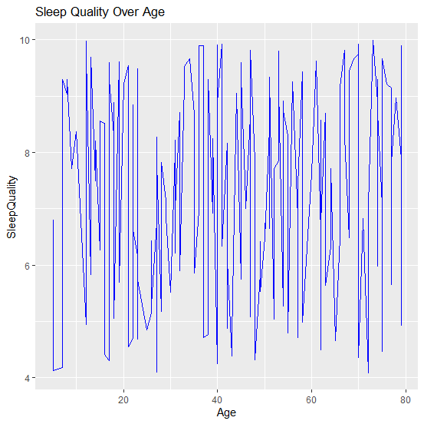
# Line Plot
ggplot(data, aes(x = Age, y = SleepQuality)) +
geom_line(color = "blue") +
labs(title = "Sleep Quality Over Age")

Multivariate Graphs in R
- Pairs Plot (Base R – Scatterplot matrix of multiple variables)
pairs(data[, c("Age", "BMI", "SleepQuality", "LungFunctionFEV1")],
main = "Scatterplot Matrix",
col = "steelblue", pch = 19)
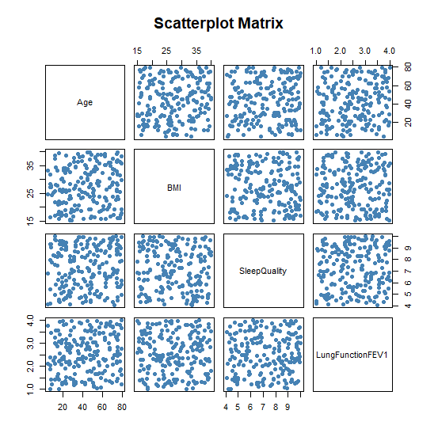

- ggpairs() from GGally (Prettier version)

install.packages("GGally")
library(GGally)

ggpairs(data[, c("Age", "BMI", "SleepQuality", "LungFunctionFEV1")])

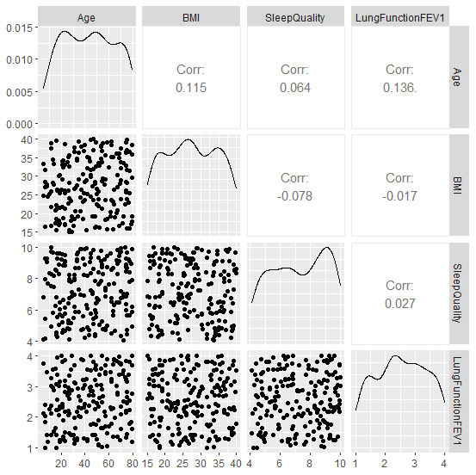

- Color-Grouped Scatter Plot (e.g., Age vs BMI, colored by DustExposure)
library(ggplot2)

ggplot(data, aes(x = Age, y = BMI, color = as.factor(DustExposure))) +
geom_point(size = 3) +
labs(title = "Age vs BMI Colored by Dust Exposure",
x = "Age", y = "BMI", color = "Dust Exposure")
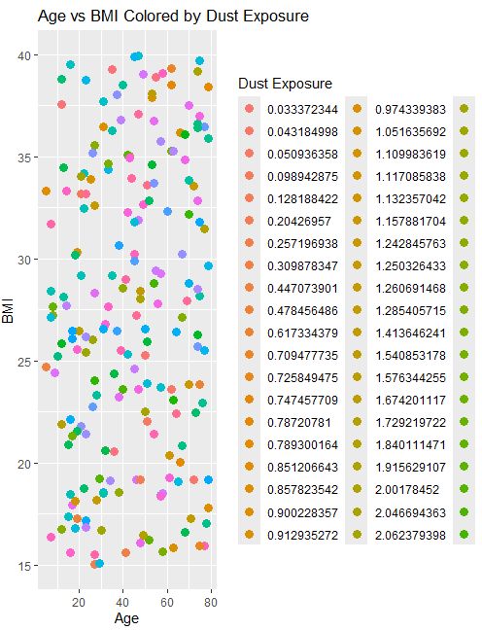

- Bubble Plot (Add 3rd variable as size)
ggplot(data, aes(x = BMI, y = SleepQuality, size = LungFunctionFEV1, color = Age)) +
geom_point(alpha = 0.6) +
labs(title = "Bubble Plot: BMI vs SleepQuality",
size = "FEV1", color = "Age")
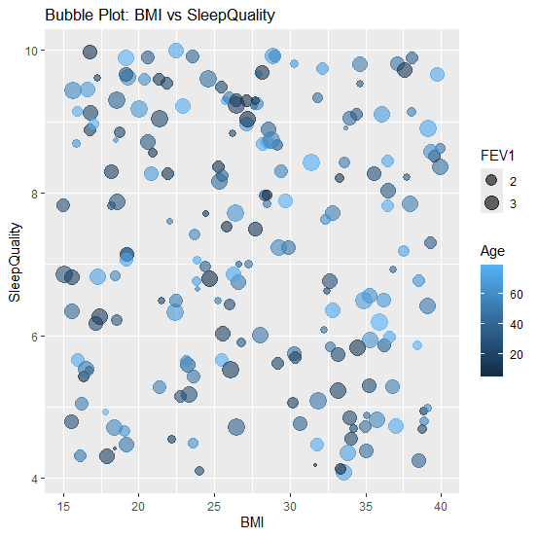

- 3D Scatter Plot
install.packages("scatterplot3d")
library(scatterplot3d)

scatterplot3d(data$Age, data$BMI, data$LungFunctionFEV1,
main = "3D Plot: Age, BMI, FEV1",
xlab = "Age", ylab = "BMI", zlab = "FEV1",
color = "blue", pch = 19)
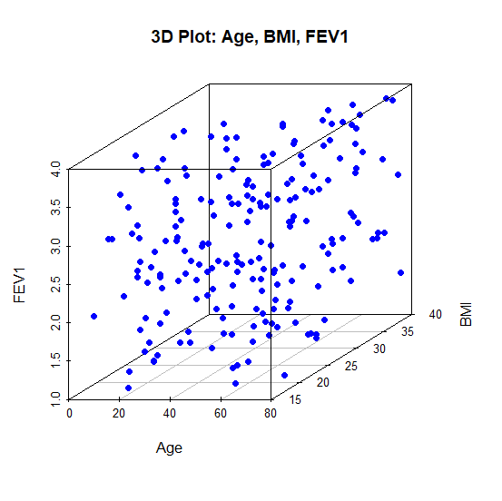
Bivariate Plots in Base R

Scatter Plot: Age vs Lung Function (FEV1)
plot(data$Age, data$LungFunctionFEV1,
main = "Age vs FEV1",
xlab = "Age", ylab = "FEV1",
pch = 19, col = "blue")

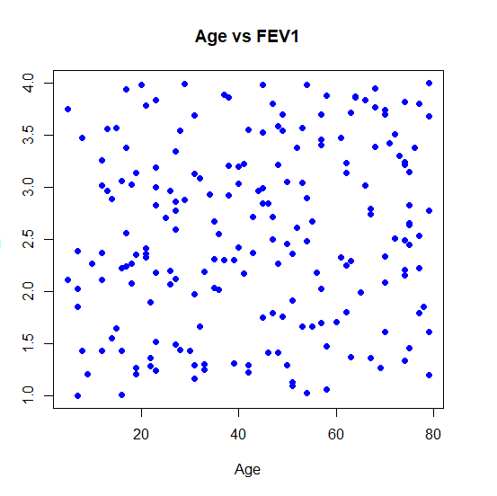
Line Plot: Age vs Sleep Quality
plot(data$Age, data$SleepQuality,
type = "l", col = "green",
main = "Age vs Sleep Quality",
xlab = "Age", ylab = "Sleep Quality")
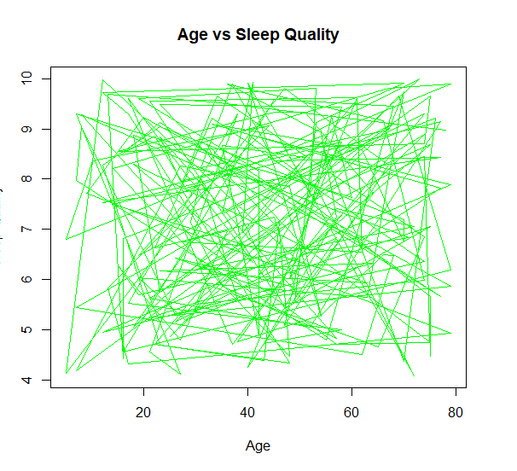
ggplot2: Smooth Line – Sleep Quality vs Age
ggplot(data, aes(x = Age, y = SleepQuality)) +
geom_smooth(method = "loess", color = "purple", se = FALSE) +
labs(title = "Sleep Quality vs Age",
x = "Age", y = "Sleep Quality")
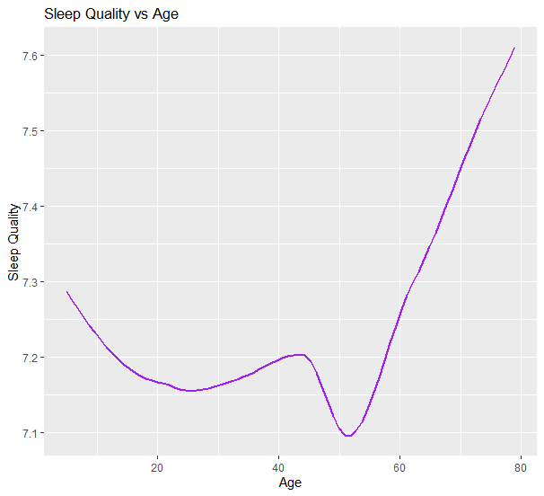

Grouped Bar Chart Using ggplot2
library(ggplot2)
library(dplyr)

# Prepare summary data
grouped_data <- data %>%
group_by(DustExposure, PollutionExposure) %>%
summarise(MeanFEV1 = mean(LungFunctionFEV1, na.rm = TRUE))

# Plot grouped bar chart
ggplot(grouped_data, aes(x = as.factor(DustExposure), y = MeanFEV1, fill = as.factor(PollutionExposure))) +
geom_bar(stat = "identity", position = "dodge") +
labs(title = "Grouped Bar Chart: Avg FEV1 by Dust & Pollution",
x = "Dust Exposure", y = "Average FEV1", fill = "Pollution Exposure") +
theme_minimal()
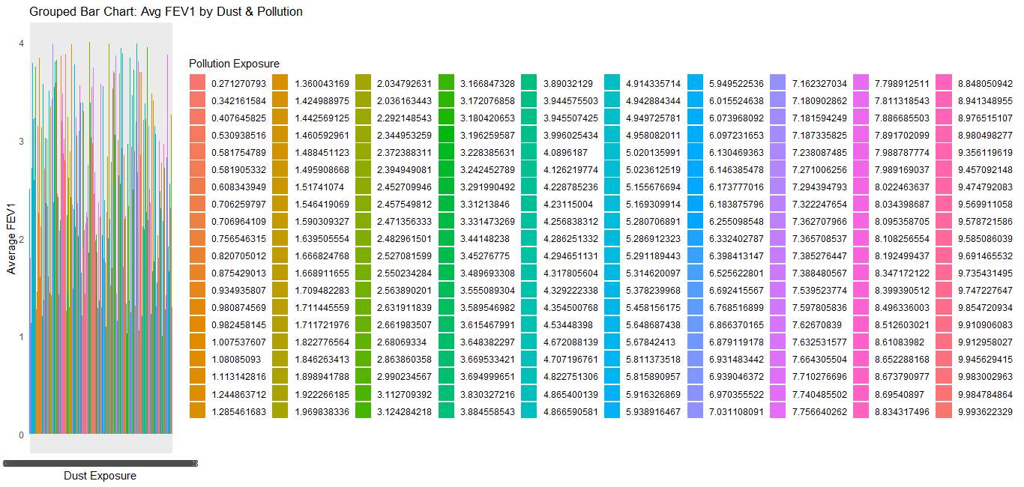

Pair plot
ggpairs(data[, c("Age", "BMI", "SleepQuality", "LungFunctionFEV1", "LungFunctionFVC")],
title = "Pair Plot of Health Indicators")

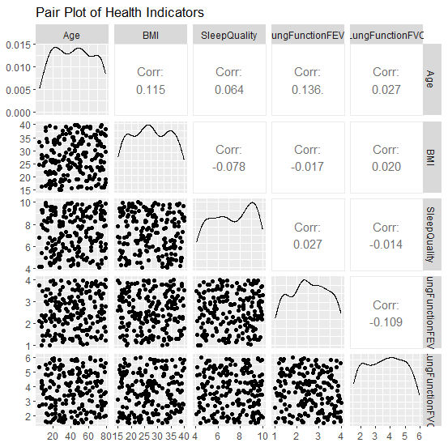
pairs(data[, c("Age", "BMI", "SleepQuality", "LungFunctionFEV1", "LungFunctionFVC")],
main = "Scatterplot Matrix",
col = "steelblue", pch = 19)
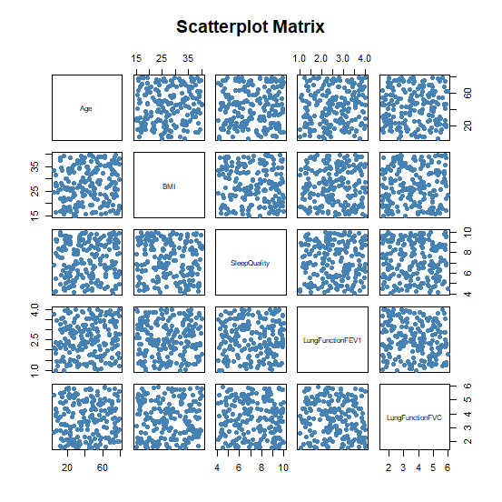
Heatmap
install.packages("reshape2")
install.packages("ggplot2")

library(reshape2)
library(ggplot2)

# Melt correlation matrix into long format
melted_cor <- melt(cor_matrix)

# Plot heatmap using ggplot
ggplot(data = melted_cor, aes(x = Var1, y = Var2, fill = value)) +
geom_tile(color = "white") +
scale_fill_gradient2(low = "blue", high = "red", mid = "white",
midpoint = 0, limit = c(-1,1), space = "Lab",
name = "Correlation") +
theme_minimal() +
labs(title = "Correlation Heatmap") +
theme(axis.text.x = element_text(angle = 45, vjust = 1, hjust = 1))
